Unity example iOS build guide

## 1. Open project and build iOS

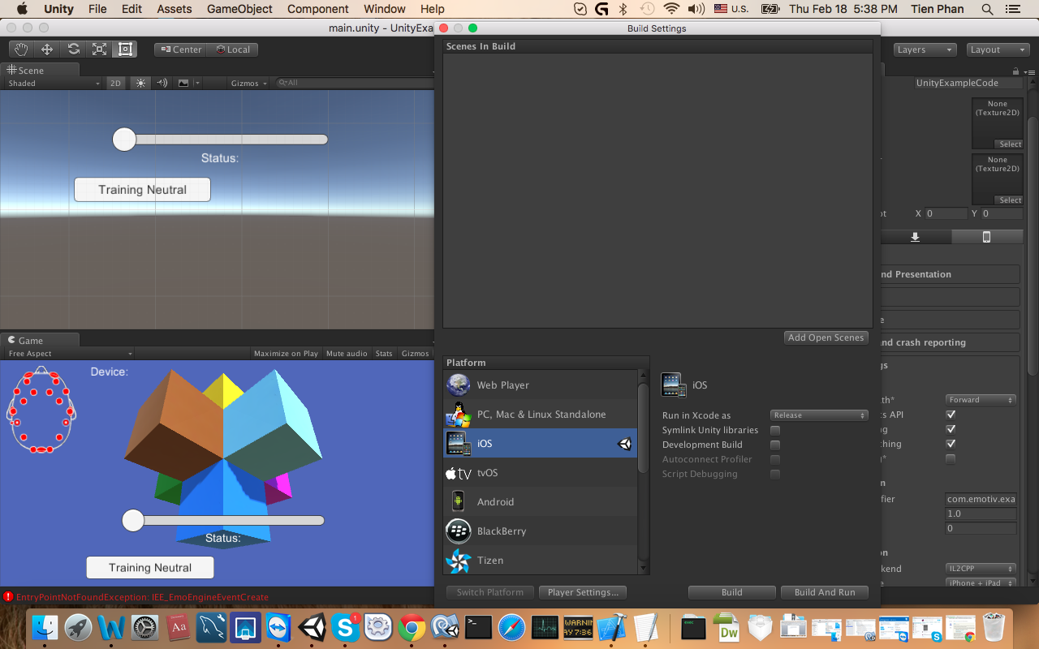

## 2. Open XCode project and add reference lib.

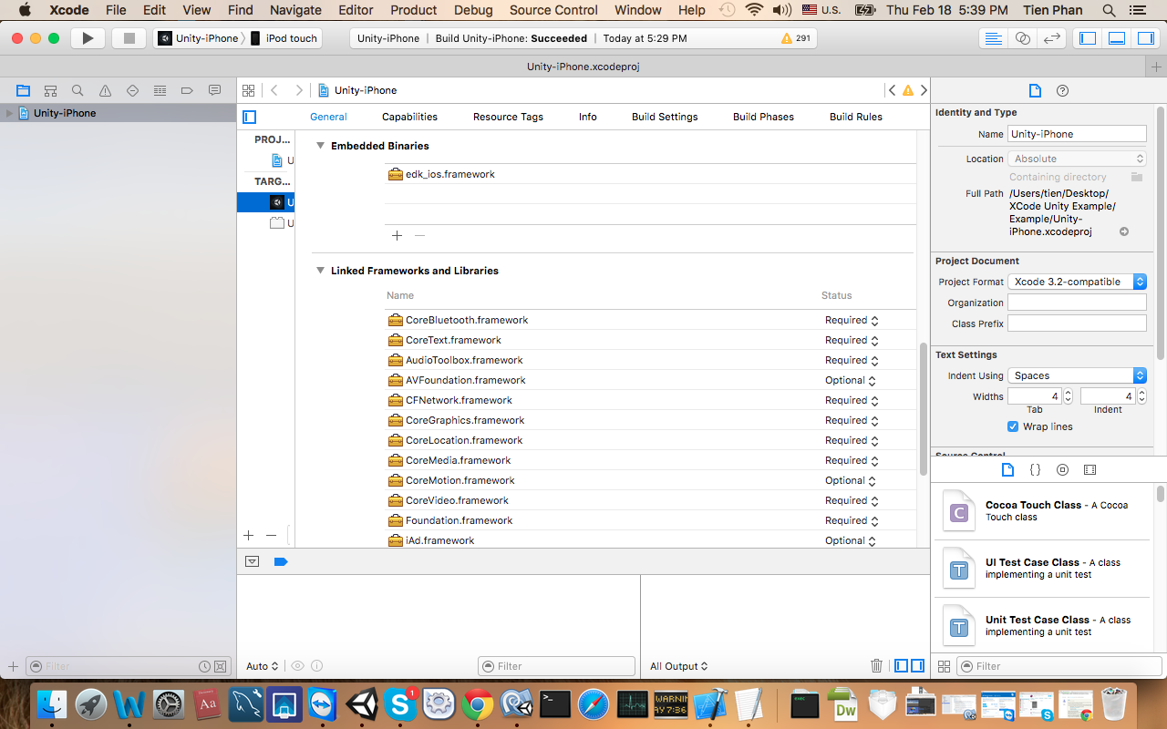

Add Embedded Lib and by press plus button then select edk_ios.framework (included in source code).

Notice: Tick to copy items if needed

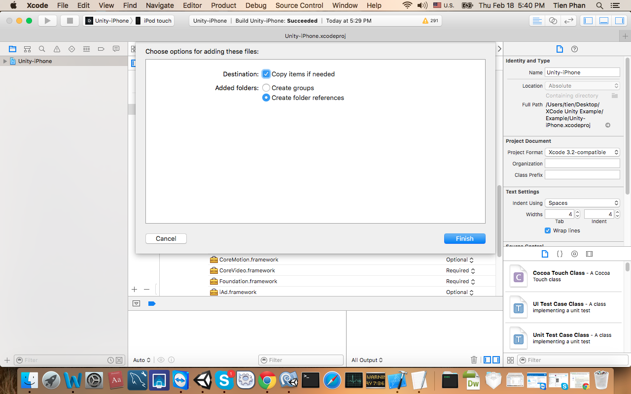

Now run in ios device. Turn on headset to connect.

